Assignment Report
The Assignment report submitted in partial fulfilment of the
requirements for
the award of the degree of
The Professional Master Of
Embedded And Cyber-Physical Systems



ECPS 216 - F'24: IOT Systems & Software Programming Assignment 3
{create a swarm to connect at most three ESP8266's and a Raspberry Pi (as a data logger)
}

Under the guidance of
Prof. Quoc-Viet Dang

Name of Candidates UCI Student ID

Sahil Kakadiya 93282494

Introduction

This project involves creating a communication network between three ESP8266 devices and a Raspberry Pi to form a "swarm" that monitors light levels. Below is an outline of how to approach the lab based on the provided requirements.
Overview
- ESP8266 devices: Each device has a light sensor (photoresistor), and the devices communicate wirelessly with each other. One device, with the highest light sensor reading, will act as the "Master" and send the data to the Raspberry Pi for logging.
- Raspberry Pi (RPi): It will log the data from the Master ESP8266 and display the results. It has a button to reset the ESP8266 swarm, and it also has four LEDs to show the status.
- Swarm dynamics: The system must work dynamically with 1–3 ESP8266 devices. The Raspberry Pi should be able to join after the Master device has been identified.

Part 1 - Raspberry Pi Wi-Fi Setup

and Packet Delivery

This code implements a server-side system in Python that operates on a Raspberry Pi, managing data received from multiple ESP8266 devices. The Raspberry Pi acts as the data logger, coordinating with the ESP8266 devices via a UDP protocol. The system uses LEDs to represent different device data conditions.

1. System Setup and Initialization
- GPIO Setup: The LEDs (white, red, green, yellow) and a button are connected to specific GPIO pins on the Raspberry Pi.
- Status Enum: The STATUS enum class represents different states (e.g., IDLE, WIFI_CONNECTED, etc.), guiding the main state machine logic.
- Networking: The system configures a UDP socket to communicate with ESP8266 devices, using the broadcast IP 255.255.255.255 and port 54321.

2. Wi-Fi and Socket Handling
- Wi-Fi Check and Reconnect: The check_wifi method verifies Wi-Fi connectivity by attempting a connection to Google’s public DNS. If disconnected, it reconfigures the Wi-Fi settings with reconnect_wifi.
- Socket Initialization and Deactivation: The system initializes a UDP socket for communication, setting a timeout for receiving data, and deactivates the socket during shutdown.

3. LED Control
- LED Reset and Mapping: reset_leds turns off all LEDs initially, and LED_MAPPING_DICT keeps track of which ESP8266 device corresponds to each LED color.
- Blink Control: The blinkRED, blinkGREEN, and blinkYELLOW methods manage LED blinking rates based on the light-dependent resistor (LDR) sensor data. map_value adjusts LDR values to set a flashing frequency within a specified range.
- Flashing Frequency Calculation: The blink function adjusts the flashing frequency of LEDs based on the LDR value. This allows a dynamic visual representation of sensor data.

4. UDP Message Handling
- Start/Stop Handshake: The start_handshake and stop_handshake methods send ONLINE and RESET messages, respectively, to initiate or stop communication with ESP8266 devices.
- Sensor Data Handling: receive_sensor_data waits for sensor data from ESP8266. The handle_sensor_data method processes the data, maps it to an LED based on its ID, and adjusts blinking accordingly.

5. Button Interaction and State Machine
- Button Press Handling: The button, when pressed, triggers transitions between states (e.g., from WIFI_CONNECTED to SEARCHING_AND_COMMUNICATING, or to STOP).
- State Machine Loop: The run method implements a main loop that transitions through different states:
  - IDLE: Attempts Wi-Fi connection.
  - WIFI_CONNECTED: Awaits a button press.
  - SEARCHING_AND_COMMUNICATING: Initializes the socket and initiates communication with ESP8266.
  - START: Receives sensor data, maps it to LEDs, and adjusts blink rates.
  - STOP: Resets LEDs, stops handshake, and deactivates the socket, returning to IDLE.

Graphical Flowchart for Raspberry Pi Program:

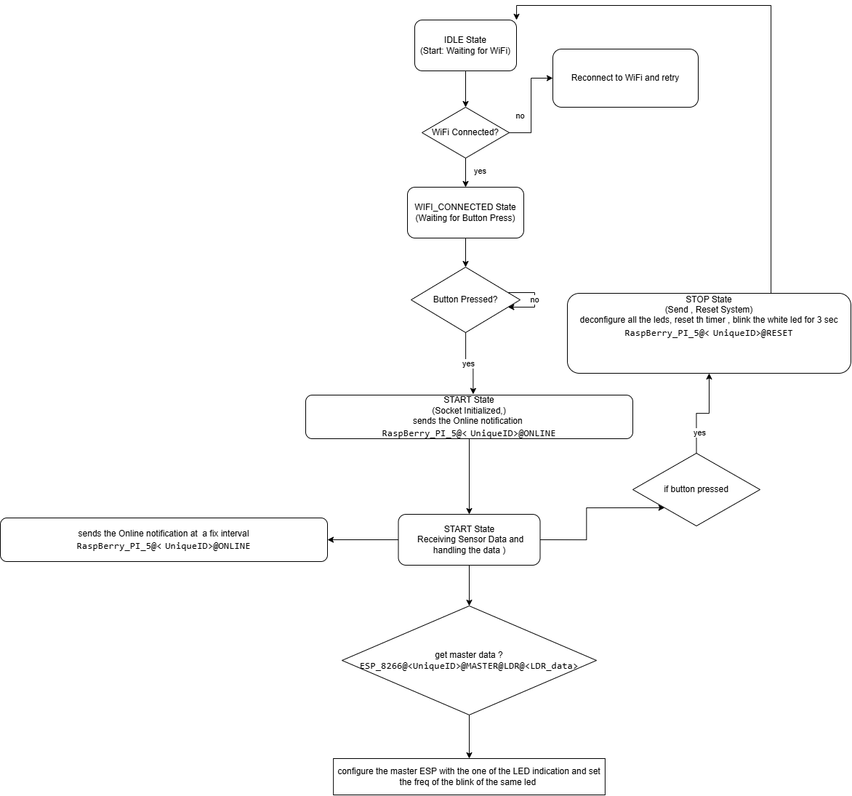

Schematic of the Raspberry PI connections:

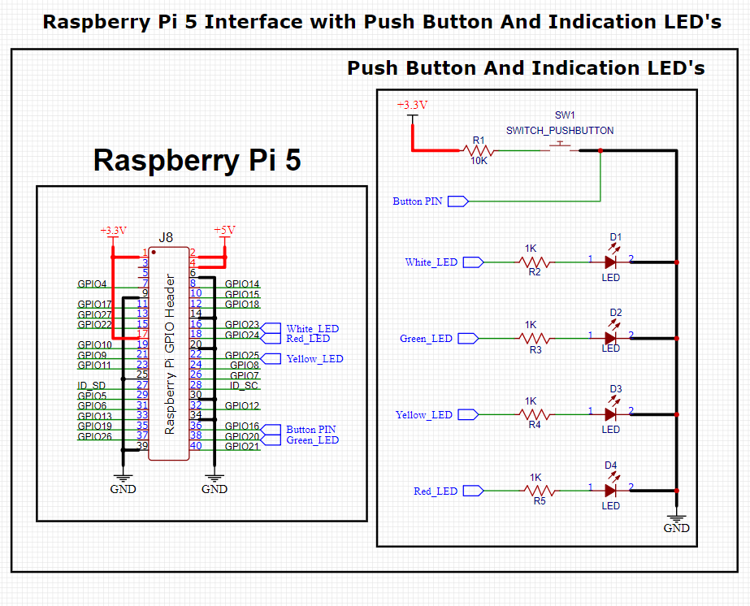

Part 2 - ESP8266 Wi-Fi Setup

and Packet Delivery

This sets up a small network of ESP8266 devices with a Raspberry Pi server. The ESP8266 devices, equipped with light sensors (photoresistors), broadcast their readings over Wi-Fi. They designate a "master" device based on light intensity, which communicates data to a Raspberry Pi. Let's go through the code step-by-step.

1. Wi-Fi and Device Setup
- The program connects the ESP8266 to a predefined Wi-Fi network.
- The ESP8266’s IP address and a unique identifier (derived from its MAC address) are assigned.
- Device roles are tracked using an enum (DeviceStatus) for states like IDLE, ACTIVE, and MASTER.

2. UDP Communication
- The code uses UDP for broadcasting packets over the network, initializing communication on a common broadcast IP (255.255.255.255) and port (54321).
- Multiple ESP8266 devices and a Raspberry Pi communicate with each other via UDP messages.
- WiFiUDP handles packet reading and writing functions for data exchange.

3. Device Configuration and Status Tracking
- Each ESP8266 maintains a configuration structure (DeviceConfig) that includes:
  - A unique identifier (UniqueID), IP address, ports for listening/sending, and the light sensor reading (LDR_reading).
  - The master device status (isMaster) is set based on LDR readings.
- The Raspberry Pi configuration is tracked separately using ServerConfig.
- When the Raspberry Pi sends a "RESET" command, devices are reset and de-configured.

4. Broadcasting and Incoming Data Handling
- broadcastData: Regularly broadcasts the device's LDR reading across the network.
- processIncomingPackets: Processes incoming packets to determine if they are from another ESP8266 or from the Raspberry Pi.
- handleIncomingPacket: Handles each packet based on its source:
  - If the packet is from the Raspberry Pi, it is passed to RPI_IncomingPackets.
  - If the packet is from another ESP8266, it is handled by ESP8266_IncomingPackets.

5. Checking and Assigning Master Status
- Master Selection: checkandsetMaster scans through configured devices to find the one with the highest LDR reading, assigning it as the "master."
- Indication: The master device lights up the master LED (LED_MASTER_PIN) to visually indicate its status.

6. Data Transmission to Raspberry Pi
- The master device sends its LDR reading to the Raspberry Pi through sendToRPi.
- The format of the transmitted message includes the device token, master status, unique ID, and LDR reading.

7. Sensor Reading and Light Intensity Mapping
- LDR Reading: readLDR reads the light intensity and updates LDR_reading. This reading determines the device's "master" status if it has the highest reading.
- LED Intensity: intensityIndication maps the LDR reading to a flashing frequency for the LED, simulating changes in light intensity by adjusting the blink rate of the LED.

8. Device Status Maintenance
- The ESP8266 devices check for inactivity in other devices and de-configure them if they miss periodic online notifications (OnlineNotification).
- CheckOnlineCountDown reduces the countdown timer for each device; if the countdown reaches zero, the device is de-configured.
- This mechanism prevents inactive devices from occupying slots in the network.

9. Summary of Key Functions
- Setup Functions:
  - setup: Initializes Wi-Fi, assigns device IDs, and configures UDP communication.
- Loop Functions:
  - loop: Repeatedly processes incoming packets, reads the LDR, and maintains device configuration.
- Configuration and Broadcast:
  - device_deConfigure: Resets device configuration.
  - broadcastData and OnlineNotification: Ensure devices are regularly broadcasting their status and data.

Schematic of the 3 X ESP8266 connections:
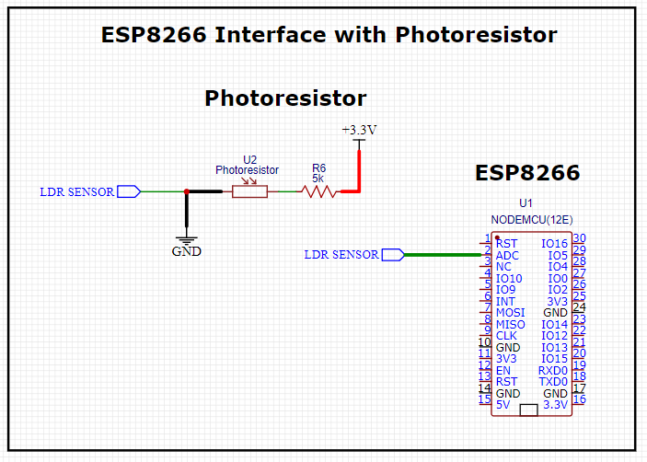

Graphical Flowchart for ESP8266 Program:
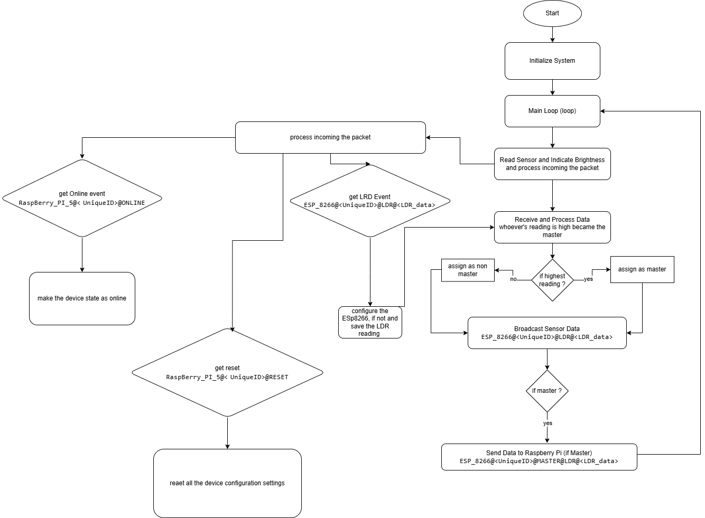

Part 3- Packet Transfer details

Packet Information:
- ESP8266 to other Esps and Raspberry Pi:
  - Online notification: "ESP_8266@<UniqueID>@ONLINE"
  - Master reading: "ESP_8266@<UniqueID>@MASTER@LDR@<LDR_reading>"
  - Broadcast message (e.g., LDR data): "ESP_8266@<UniqueID>@LDR@<LDR_reading>"
- Raspberry Pi to ESP8266:
  - Online notification: "RaspBerry_PI_5@<UniqueID>@ONLINE"
  - Reset command: "RaspBerry_PI_5@<UniqueID>@RESET"

Packet Flow and Sequence:
- ESP8266 Device Broadcasts LDR Data:
  - Packet:
ESP_8266@<UniqueID>@LDR@<LDR_data>
Example: ESP_8266@ESP_1234@LDR@512
  - Recipient: other ESP8266 devices
- ESP8266 Device Broadcasts ONLINE Message to All Devices:
  - Packet:
ESP_8266@<UniqueID>@ ONLINE
Example: ESP_8266@ESP_1234@ ONLINE
  - Recipient: Raspberry Pi (RPi) or other ESP8266 devices
- Raspberry Pi Sends "ONLINE" Message to All ESP8266 Devices:
  - Packet:
RaspBerry_PI_5@< UniqueID>@ONLINE
Example: RaspBerry_PI_5@RPi_1@ONLINE
  - Recipient: All ESP8266 devices
- ESP8266 Devices Compare LDR Values:
  - Each ESP8266 device compares its LDR reading with others. The device with the highest reading becomes the Master.
- Master Sends Master Data to Raspberry Pi:
  - If the device is the Master, it sends the following message to the Raspberry Pi:
Packet:
ESP_8266@<UniqueID>@MASTER@LDR@<LDR_data>
Example: ESP_8266@ESP_1234@MASTER@LDR@512
  - Recipient: Raspberry Pi (RPi)
- Raspberry Pi Sends "RESET" Command to All ESP8266 Devices:
  - Packet:
RaspBerry_PI_5@< UniqueID>@RESET
Example: RaspBerry_PI_5@RPi_1@RESET
  - Recipient: All ESP8266 devices

Part 4 – Schematic
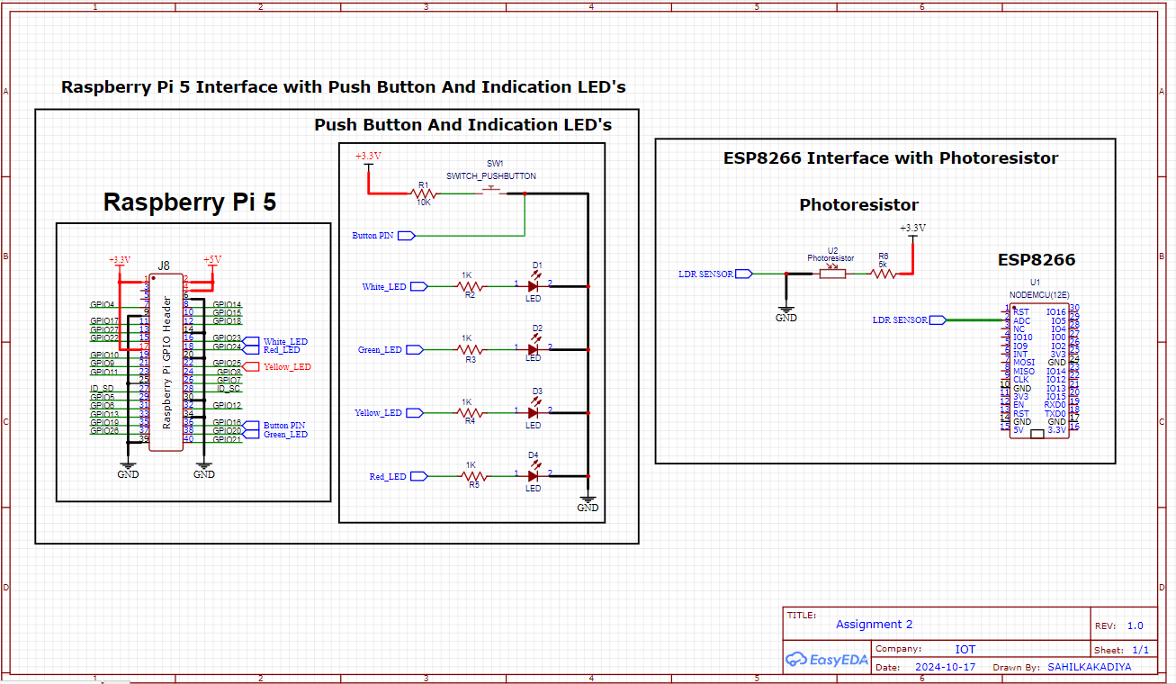

Explanation of the Interface Between Raspberry Pi 5, 3X ESP8266 (diagram shows only one, but all the other ESP8266’s hardware is same ), and External Components (Push Buttons, LEDs, LDR Sensor)
1. Raspberry Pi 5 Interface with Push Button and LED Indicators
- GPIO Pins:
  - The General-Purpose Input/Output (GPIO) pins on the Raspberry Pi 5 are used to interface with external components like push buttons and LED indicators.
  - The Raspberry Pi's GPIO header (J8) has multiple pins, including 3.3V, 5V, GND, and several programmable input/output pins. These GPIO pins allow the Raspberry Pi to receive signals (e.g., from a push button) or send signals (e.g., to LEDs to turn them on or off).

- Push Button (SW1):
  - A push button is connected to one of the GPIO pins of the Raspberry Pi.
  - One side of the push button is connected to the GPIO pin via a 10kΩ resistor (R1), acting as a pull-down resistor. This ensures that when the button is not pressed, the GPIO pin reads a LOW signal (0V).
  - The other side of the button is connected to 3.3V. When the button is pressed, the GPIO pin is pulled high (3.3V), and the Raspberry Pi can detect this state change as a button press.
- LED Indicators:
  - Four LEDs are connected to separate GPIO pins, allowing the Raspberry Pi to control each LED individually by sending signals through these pins.
  - Each LED has a 1kΩ current-limiting resistor connected in series with it to protect the LED and the Raspberry Pi's GPIO pins from excessive current.
  - The following LEDs are connected:
    - White LED via resistor R2
    - Green LED via resistor R3
    - Yellow LED via resistor R4
    - Red LED via resistor R5
  - The Raspberry Pi can turn these LEDs on or off by toggling the GPIO pin to HIGH (3.3V) or LOW (0V).
- Power and Ground:
  - The 3.3V and 5V pins on the Raspberry Pi provide power to components that need it, like sensors or circuits.
  - All components (push button and LEDs) are grounded via the GND pin of the Raspberry Pi, ensuring a complete electrical circuit for proper functioning.

2. 3X ESP8266 Interface with LDR Sensor
- LDR (Photoresistor) Sensor:
  - The Light Dependent Resistor (LDR) is used to measure light intensity. Its resistance varies based on the amount of light falling on it — the more light, the lower its resistance, and vice versa.
  - This change in resistance is used to create a voltage divider circuit with a fixed resistor.

- Voltage Divider Circuit:
  - One side of the LDR is connected to +3.3V, which provides power to the sensor.
  - The other side of the LDR is connected to GND through a 5kΩ resistor (R6). This forms a voltage divider, which means that the voltage at the point between the LDR and the resistor changes depending on the light intensity sensed by the LDR.
  - As the LDR's resistance changes with light intensity, the voltage at the point between the LDR and the resistor also changes. This voltage is proportional to the light intensity.
- ADC Pin on ESP8266:
  - The Analog-to-Digital Converter (ADC) pin of the ESP8266 (Pin A0) is connected to the point between the LDR and the 5kΩ resistor. The ADC pin reads the varying voltage from the voltage divider circuit.
  - The ESP8266 has only one ADC pin (A0), which can measure voltages between 0V and 1V. Any higher voltage needs to be scaled down appropriately (usually done with resistors or a voltage divider).
  - The ESP8266 uses the analog voltage signal from the LDR to interpret the current light level. This information can then be processed, transmitted over Wi-Fi, or used to control other devices.

